**Enzymes – Notes**

Factors affecting enzyme activity:

1. Temperature – Optimal temperature is 37.7°C. Too high and the enzymes denature. Too low and the enzymes slow down too much.
2. pH – Enzymes have specific pH’s that they function in.
3. Presence of co-factors/coenzymes – Substances such as vitamins and minerals act to enhance enzyme activity. Enzymes become more efficient in their presence.
4. Amount of substrate – The more substrate, the more molecules that the enzymes can bind to and the more the enzyme activity. However, once all the substrate has been taken up, enzyme activity slows down.
5. Enzyme inhibitors – Some substances act to slow enzyme activity.
6. Concentration of enzymes – The higher the concentration, the faster the activity.
7. Product removal – At the end of the enzyme-substrate reaction, products are formed. Generally, the higher the amount of product, the slower the removal of the product and the slower the enzyme activity.

There are 2 types of metabolic reactions:

1. Catabolic reactions – Large molecules are broken down into smaller molecules.

* Energy is released.
* Example – Cellular respiration.

1. Anabolic reactions – Small molecules are built up into larger molecules.

* Example – Protein synthesis.

Lock & key model:

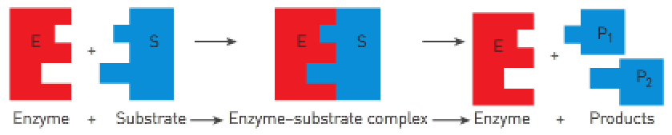

* Most chemical processes in the body occur far too slowly to sustain life. The **activation energy is very high**.
* Activation energy: The **energy required for the reaction to proceed**.
* Special proteins called enzymes **reduce the activation energy** of reactions – they **speed up chemical reactions**.
* Enzymes: **Protein catalysts** that **speed up** the rate of metabolic reactions.

Q: What did the pineapple jelly experiment demonstrate?

The fresh pineapple contains protease enzymes which stop the jelly (gelatin protein) from setting.

Q: If you heated the content of Cup A then left it to stand in the refrigerator, would it set?

If heated enough, the protease enzymes would denature. Therefore, the jelly would set.

Q: What would you expect to occur if you used fresh frozen fruit in the preparation of the jelly in the cups?

If you used fresh frozen fruit, the temperature would decrease the enzyme activity. It would therefore take longer to set.

Q: What did the marbles in the measuring cylinders experiment demonstrate?

The marbles demonstrated that the further they fell, the less the jelly had set. If the jelly has set less, it’s because a protease enzyme has stopped the gelatin (a protein found in jelly) from setting.

Q: Which containers were used as controls in each experiment? Why was this necessary?

The canned pineapple was used as a control because no protease enzyme was present. To a lesser extent, the meat tenderizer would also be a control because it breaks down the gelatin bonds but doesn’t have protease enzyme to do it.

Independent variable – The amount of protease enzyme.

Dependent variable – The rate at which the jelly had set.

Q: What does the speed of the movement of the marble indicate about the activity of the enzymes present in the additives?

The faster the marble’s speed, the further it will go and the more the protease enzyme is present. This is because the protease breaks the gelatin, so it isn’t as thick.

Q: How could you make the marble move faster without melting the jelly?

Add more protease enzyme and tenderizer.

Q: Why is the meat tenderizer added to the marinades and stews that use cheap cuts of meat?

Cheap cuts of meat are tougher and “stringier”. Meat tenderizer breaks the protein bonds so that they’re easier to eat.